Data Confirmation 2020/21
Instructions

Step 1: Login to https://my.iusd.org

• Enter your email address and password (this is your Parent Portal login information)
- Parent portal accounts are automatically created when a student has enrolled in IUSD.
- If you DO NOT have a parent portal account, please contact the front office staff at your student’s school to request your email address be added to the contact record of your student. Once the email address is added or updated, your parent portal account will automatically be created and you will receive an email from DoNotReply@iusd.org with your account information.
- If you forgot your password, please click on “Forgot Password?”
- If you need assistance logging in, please contact the front office at your child’s school or
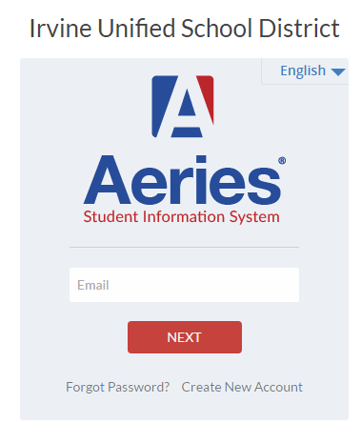
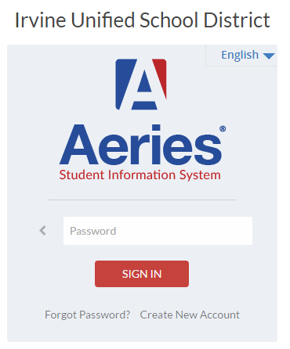
contact help desk at helpdesk@iusd.org.

Step 2: Select Student

• Once you login, the system will default to your child.
- If you have more than one child, you will need to move your cursor over “Change Student” in the upper right hand corner of the screen. Please note that Data Confirmation must be completed for each student.

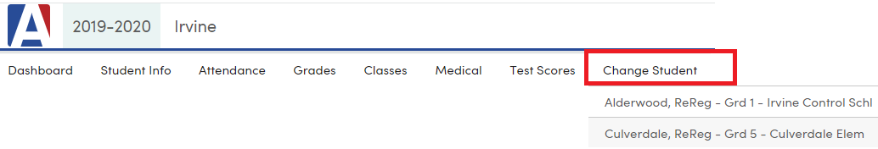

Step 3: Student Data Confirmation Process

- In the Student Info Tab, please click on “Data Confirmation”. Please complete each of the tabs listed below and follow the instructions provided.

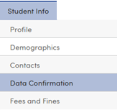
- Family Information
This section includes a MILITARY SURVEY. PLEASE READ CAREFULLY. THIS IS A MILITARY/UNITED STATES ARMED FORCES FAMILY QUESTIONNAIRE: As a part of the new accountability requirements under the Every Student Succeeds Act (ESSA), the U.S. Department of Education is requiring school districts to identify students who are United States armed forces family members. Once you select "Yes" or "No", please click the “Confirm and Continue” button.
2. Student
Update any changes by clicking on the “Change” button on the bottom of the page. Once changes are complete, please “Save” then click on “Confirm and Continue”.
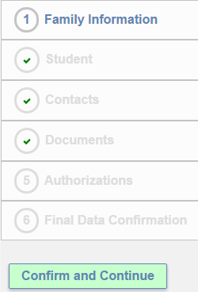
3. Contacts
Change/Add/ Delete contacts in this tab. Once changes are complete, please “Save” then click “Confirm and Continue”.
4. Documents
Please read each document in this section, and follow the instructions listed. Some documents will need to be printed and returned to your child’s school. You cannot continue with the confirmation process until you read and confirm all of the documents listed on this tab. Once all documents have been read, please click “Confirm and Continue”.
5. Authorizations
Please review all information on this screen with your child and click Allow or Deny when appropriate. Once complete, please click “Save” at the bottom of the page. Then click “Confirm and Continue”.
6. Final Data Confirmation
Please confirm that all information has been read and that you have completed the online data confirmation process. Once complete, please click the Finish and Submit button. Follow any further instructions listed. Please note: the system will not allow you to perform Final Data Confirmation until all the previous tabs have been complete.

Updated 5/20/20

